Family of Robert Llewellyn Poppett and Martha Pugh

**Robert Llewellyn Poppett** (RLP) was born 02 Apr 1806[1] in Worthen Shropshire, England, to Robert Poppit (1774-1838), a widower, and Elizabeth Llewellyn (1774-1836), both of Churchstoke. RLP was baptized 09 Apr 1806 in Churchstoke, Montgomeryshire, Wales.

RLP married **Martha Pugh** (b 1810 in Hope, Shropshire, England) on 10 Jun 1833 at All Saints Church, Worthen, Shropshire, England.[2] He made his mark and Martha signed. Martha was a daughter of **John Pugh** (1761-1841) and **Catherine Davies** (1765-1844). [3]

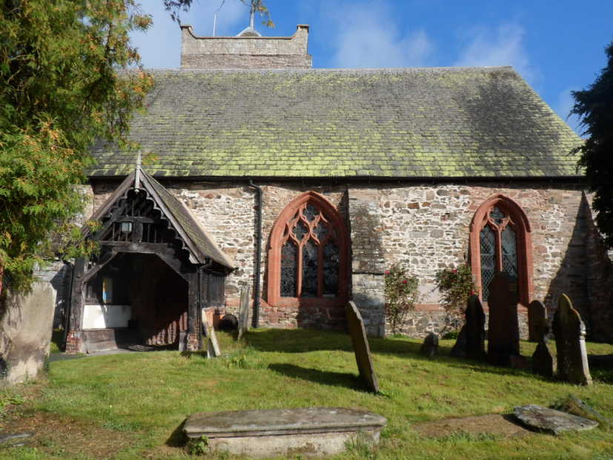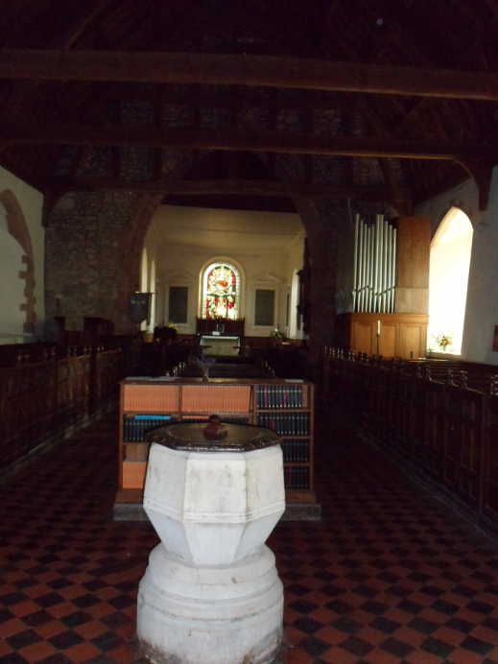

Their son John was born in 1834 in Shropshire. [4] Daughter Elizabeth was born in 1835 in Shrewsbury, Shropshire, England[5].

Robert and Martha’s third child and second son, **Robert Albert[6]** (RAP), was born 12 Apr 1839 in Bentlawnt, Shropshire, England[7] and like his siblings, baptized at the All Saints’ Church in Worthen.

The family lived in Worthen, Shropshire in 1841. All 3 children were present in the household. Robert was a lead miner.[8]

Daughter Ann was born 18 Mar 1842 in Bentlawnt[9].

Daughter Jane was born in Bentlawnt in 1843.[10]

Wife Martha died 25 Mar 1844[11]; baby Jane died 5 Jun 1844[12], both in Bentlawnt. Per Martha’s death certificate, Robert was a shoemaker at this time.[13]

1. Baptism certificate in his profile
2. Copy of marriage certificate attached to RLP profile
3. From chris099: I have found Martha Pugh's brothers & sisters; I am at the moment looking for Catherine Davies sisters & brothers but I can only find a sister Mary born in 1762. I have also found a death for Martha parents John & Catherine which I am going to add. Just added MC for John & Catherine Pugh , Martha's parent's, also found Martha's brother William's baptism in Chirbury, I will try and find the other baptisms.”
4. *England, Select Births and Christenings, 1538-1975; copy of register in his profile*
5. *England, Select Births and Christenings, 1538-1975; copy of register in her profile*
6. Robert gave a middle name “Albert” on his naturalization documents: U.S. Naturalization Record Indexes, 1791-1992 NARA Washington, D.C.; Index to Naturalization Records of the U.S. District for the Southern District of California, Central Division (Los Angeles), 1887-1937 (M1607); Microfilm Serial: M1607; Microfilm Roll:
7. RAP’s birth certificate and baptism register notes in his profile
8. Class: HO107; Piece 909; Book: 21; Civil Parish: Worthen; County: Shropshire; Enumeration District: 8; Folio: 10; Page: 13; Line: 15; GSU roll: 474584.
9. Birth certificate and baptism register in her profile.
10. Birth certificate and baptism register in her profile.
11. Death certificate and burial register in her profile
12. Death certificate and burial register in her profile
13. Chris099: “I went over to Worthen a couple of months ago to look for Gravestones but I could not find any.” 